John Bower Funk
June 11, 1862 – March 12, 1940

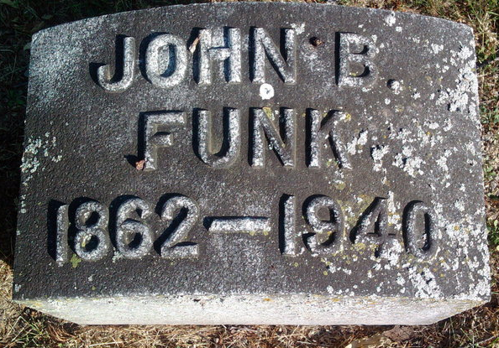
Photo by Thomas Liby

JOHN B. FUNK IS CALLED BY DEATH
Former Liberty Center Postmaster and Druggist Dies At Hospital

John B. Funk, 77, former Liberty Center postmaster and druggist, died here at `2:15 this afternoon at the Wells county hospital, where he had bee receiving treatment the past ten days for a bowel obstruction and complications.
He was one of the most prominent residents of Liberty Center, where he operated a drug store for 35 years and served as postmaster 29 years.
He was born in Ohio on June 11, 1862, a son of Absalom and Ann Bower Funk. His parents were pioneer settlers in Liberty township, having moved to that township 73 years ago. His marriage to Hannahs S. Rinear took place on April 2, 1885. He was a member of the Baptist church and I. O. O. F. lodge at Liberty Center.
Surviving besides the widow are a son, John A. J. Funk, of Galveston, Ind., and a daughter, Mrs. Homer Johnson, of Liberty Center. A Son Charles Funk is deceased. Five grandchildren and one great-grandchild survive. Two sister surviving are Mrs. Susan Garrett and Mrs. Rachel Bowman, of Liberty Center. Four brothers, Henry, Martin, Benjamin and Jacob, preceded him in death.
Funeral services will be held at 2 p.m. Thursday at Liberty Center Baptist church, with burial in Fairview cemetery.

Evening News Banner, Wells County, Indiana
Tuesday, March 12, 1940, p. 1, c. 4
**

Illness Fatal to John B. Funk

Bluffton, Mar. 12 – John B. Funk, 77, former Liberty Center druggist and postmaster, died at 12:30 o’clock this afternoon at the Wells County Hospital here, following an illness of bowel construction. He was one of Liberty Center’s most prominent citizens and operated a store there 35 years, during 20 years of which he served as postmaster. He was a member of the Baptist Church and the I.O.O.F. Lodge at Liberty Center.
Surviving are the widow, formerly Hannah S. Rinear; one son, John A. J. Funk of Galveston; one daughter, Mrs. Homer Johnson of Liberty Center; five grandchildren and a great-grandchildren and two sisters, Mrs. Susan Garrett and Mrs. Rachel Bowman of Liberty Center.
Funeral services will be held at 2 pm Thursday at the Liberty Center Baptist Church and burial will follow in Fairview Cemetery at Bluffton.

Journal-Gazette, Allen County, Indiana
March 13, 1940

