Hannah S. (Rinear) Funk
December 28, 1866 – December 30, 1942

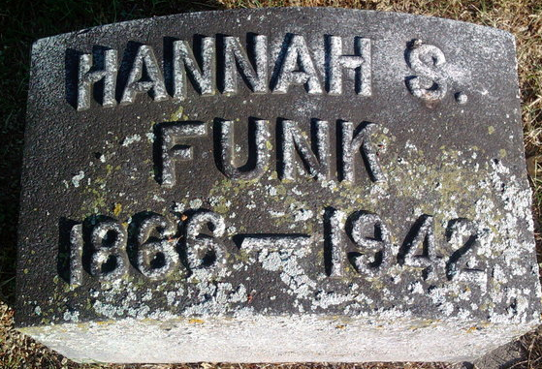
Photo by Thomas Liby

Indiana, U.S., Death Certificates, 1899-2017
Name Hannah Funk (indexed as Frunk)
[Hannah Rinear]
Gender Female
Race White
Marital Status Widowed
Age 76y 0m 2d
Birth Date 28 Dec 1866
Birth Place Liberty Center, Indiana
Death Date 30 Dec 1942
Death Place Bluffton, Wells, Indiana, USA
Cause of death Fell down stairs
Death Registration Date 1942
Father J W Rinear
Mother Sarah C First
Spouse John B Funk
Informant Mrs. Homer Johnson, Liberty Center, IN
Burial 1/1/1943 Fairview

