Mary (Mossy) Fulton
1853 – June 15, 1892

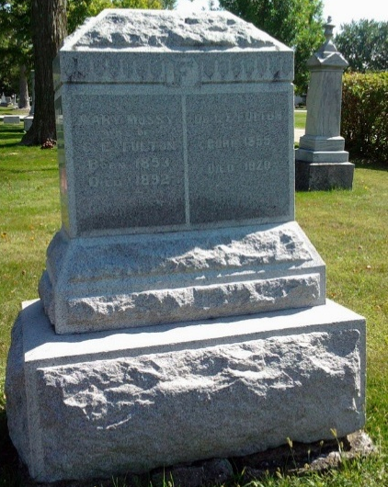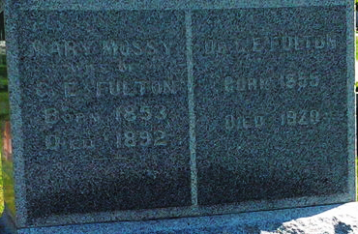
Photo by Thomas Liby

Indiana, U.S., WPA Death Index, 1882-1920
Name Mary Fulton
Date Jun 15, 1892
Location Wells County
Age 39 Yr
Gender Female
Race White
Source location County Health Office, Bluffton
Source notes The source of this record is the book H-14 on page 42 within the series produced by the Indiana Works Progress Administration.
**
Indiana, U.S., Marriage Index, 1800-1941
Name Mary Mossy
Marriage Date 28 Sep 1881
Marriage Place Wells, Indiana, USA
Spouse Name George E. Fulton

