George E. Fulton, M.D.
August 10, 1855 – April 2, 1920

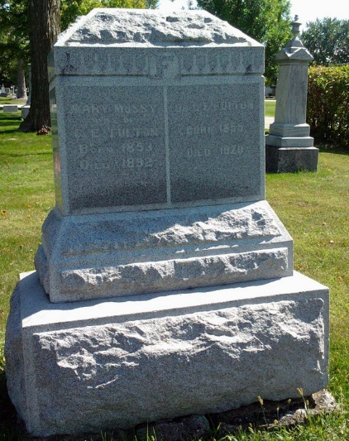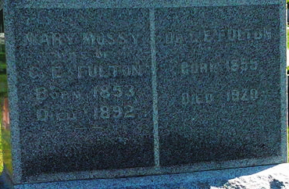
Photo by Thomas Liby

PROMINENT PHYSICIAN IS DEAD AT BLUFFTON

BLUFFTON, Ind., April 2 - Dr. George E. Fulton, 64, a prominent northern Indiana physician, died here early today following illness from influenza and pneumonia. Dr. Fulton was in the Indiana house of representatives in 1889 and 1891 and for years had been an active democrat. He was one of the first men to adopt pure food laws. A brother, Dr. J. C. Fulton, is said to be near death from intestinal cancer.

Fort Wayne News & Sentinel, Allen County, Indiana
April 2, 1920
**

Indiana, U.S., Death Certificates, 1899-2017
Name Dr George E Fulton
Gender Male
Race White
Marital Status Married
Age 64y tm 22d
Birth Date 8 Oct 1855
Birth Place Ossian Wells Co Indiana
Death Date 2 Apr 1920
Death Place Bluffton, Wells, Indiana, USA
Death Registration Date 1920
Father John Fulton
Mother Sarrah Egbert Fulton
Spouse Elizabeth (Muth) Fulton
Informant Family
Burial Fairview 4/5/1920

