Elizabeth May (Muth) Fulton
June 4, 1859 – March 5, 1944

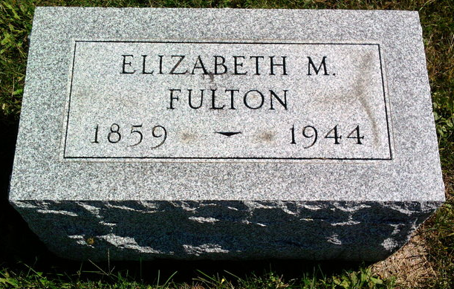
Photo by Thomas Liby

Indiana, U.S., Death Certificates, 1899-2017
Name Elizabeth M Fulton
Gender Female
Race White
Marital Status Widow
Age 84y 9m 1d
Birth Date 4 Jun 1859
Birth Place West Virginia
Death Date 5 Mar 1944
Death Place Bluffton, Wells, Indiana, USA
Father unknown b. Germany
Mother Elizabeth Bayha
Spouse George E Fulton
Informant Fannie Keelogg, Bluffton, IN
Burial Fairview 3/8/1944
**
Indiana, U.S., Marriages, 1810-2001
Name Elizabeth May Mooth
[Elizabeth May Muth]
Gender Female
Event Type Marriage Registration (Marriage)
Birth Place Fulton West, Virginia
Marriage Date 24 Oct 1894
Marriage Place Bluffton, Indiana, United States
Residence Place Bluffton
Father John Muth
Mother Elizabeth Bayha
Spouse George Egbert Fulton
Page 164

