John H. Fulk
March 11, 1876 – May 6, 1940

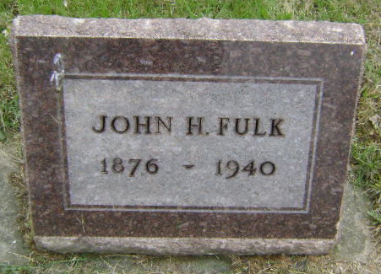
Photo by Bruce Sonner

FULK

Bluffton, May 5 – John H. Fulk, 64, Bluffton contractor and carpenter, died at 9:20 am today at his home here after an illness of a year with heart disease.
Surviving are the widow, Mrs. Martha Reppert Fulk; two sons, Ralph D. and Dwight R. Fulk of this city and one brother, Lewis P. Fulk of this city.
Funeral services will be held Monday at 3 pm (CST) at the Jahn Funeral Home here with Rev. Mathew Worthman officiating. Burial will be in Fairview Cemetery.

Journal-Gazette, Allen County, Indiana
May 6, 1940
**
Indiana, U.S., Death Certificates, 1899-2017
Name John H Fulk
Gender Male; Race White
Marital Status Married
Age 64y 1m 24d
Birth Date 11 Mar 1876
Birth Place Adams County, Indiana
Death Date 5 May 1940
Death Place Rural, Wells, Indiana, USA
Father William F Fulk
Mother Emma Sovine
Spouse Martha Reppert Fulk
Burial Fair View Cemetery 5/6/1940

