Martha Elizabeth (Reppert) Fulk
July 11, 1879 – October 13, 1959

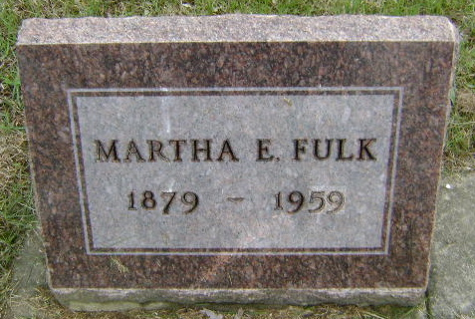
Photo by Bruce Sonner

Indiana, U.S., Death Certificates, 1899-2017
Name Martha Elizabeth Fulk
[Martha Elizabeth Reppert]
Gender Female
Race White
Marital Status Widowed
Age 80y 3m 2d
Birth Date 11 Jul 1879
Birth Place Adams County, Indiana
Death Date 13 Oct 1959
Death Place Bluffton, Wells, Indiana, USA
Death Registration Date 1959
Father Fred Reppert
Mother Louisa Seltemajor
Informant Ralph D. Fulk, son
Burial 10/15/1959 Fairview Cem.

