Robert D. Frantz
January 20, 1928 - April 6, 2011

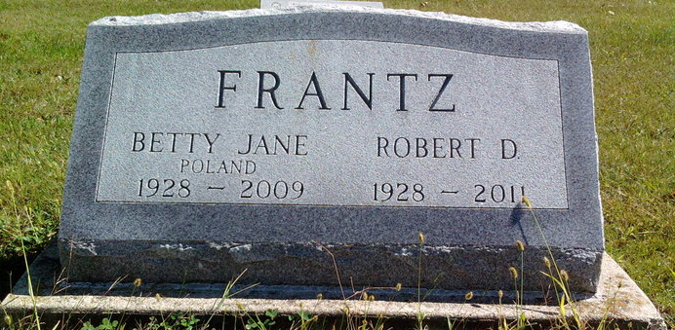
Photo by Thomas Liby

Robert D. "Bob" Frantz, 83, of Bluffton, passed away at 2:30 a.m. Wednesday, April 06, 2011 at Meadowvale Health & Rehabilitation Center.
He was born on January 20, 1928 in Wells County, Indiana to Joseph Thomas and Walkie Jane (Surbaugh) Frantz, they preceded him in death. Bob married Betty Jane (Poland) in Warren, Indiana on December 14, 1947; she preceded him in death on November 5, 2009.
A graduate of Liberty Center High School; Bob worked as a Foreman and Group Leader for Franklin Electric Company for 20 years. He also owned and operated Frantz & Associates where he provided Realtor and Auctioneer services. He was a bus driver for Southern Wells Schools for many years after retiring from Franklin Electric and he also did some farming.
Bob formerly attended the Dillman United Brethren Church, where he worked with the youth group. He was also a member of Bluffton Masonic Lodge #145.
Survivors include one son, Gerald W. "Gary" Frantz (wife: Connie) of Warren, Indiana; one daughter, Vicki J. Frantz-Shannon of Bradenton, Florida; one brother, Nyal Frantz of Clyde, Ohio and four grandchildren, Matt McFarren, Kari Baker, Nathan Frantz, and Joey Shannon. He was also preceded in death by a daughter, Connie Jo Frantz; a brother, Thomas L. Frantz and a sister, Genivee Kirkwood.
Calling hours are 1:00 to 4:00 p.m. Sunday, April 10, 2011 at Thoma/Rich, Chaney & Lemler Funeral Home. Masonic funeral rites will be conducted by Bluffton Masonic Lodge at 2:00 p.m. Sunday at the funeral home. Funeral service is at 4:00 p.m. Sunday at the funeral home with Mayor Ted Ellis officiating. Burial will be at Fairview Cemetery.
Preferred memorials are to the Alzheimer's Association or the American Cancer Society.
Thoma/Rich, Chaney & Lemler Funeral Home, Wells County, Indiana
April 8, 2011.

