Betty Jane (Poland) Frantz
November 28, 1928 – November 5, 2009

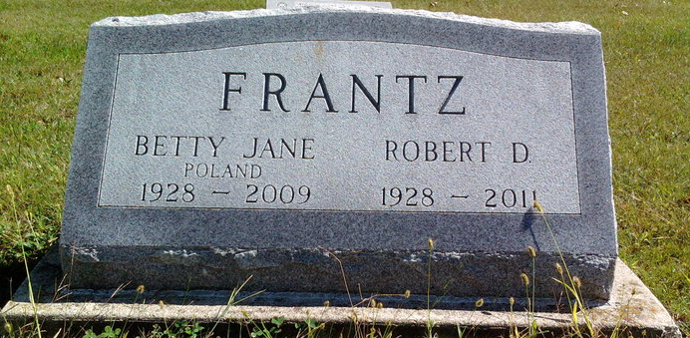
Photo by Thomas Liby

Betty J. Frantz, 80, of Bluffton, died at 8:55 p.m. Thursday, Nov. 5, 2009, at River Terrace Estates.
Mrs. Frantz was born in Flint, Mich. on Nov. 28, 1928 to Harry E. and Stella (Gagnier) Polant. She married Robert D. Frantz in Warren on Dec. 14, 1949; he survives.
Mrs. Frantz was a 1946 graduate of Rockcreek High School. She was a housewife.
Surviving relatives also include one son, Gerald W. (Connie) Frantz of Warren; one daughter, Vicki J. Frantz-Shannon of Bradentown, Fla.; and four grandchildren.
She was preceded in death by one daughter, Connie Frantz.
Calling will be from noon to 4 p.m. Sunday at the Goodwin Memorial Chapel. There will be no funeral services. Burial will be in Fairview Cemetery, Bluffton.
Memorials may be made to the American Diabetes Association.
Goodwin-Harnish Funeral Home, Wells County, Indiana

