Mary Ellen (Wible) Fox
June 13, 1925 - April 24, 2017

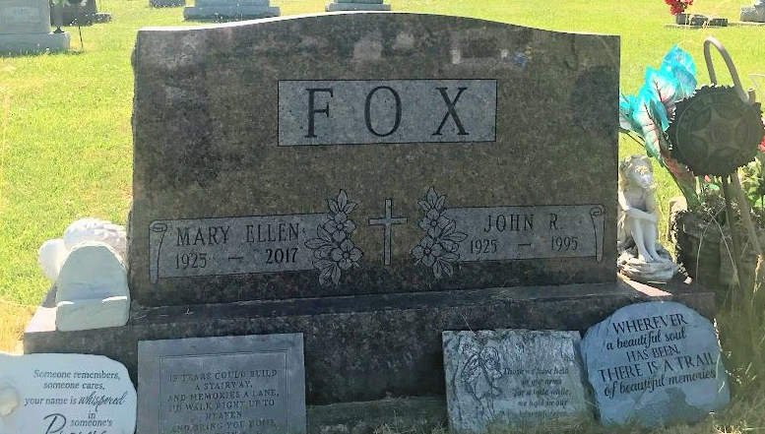
Photo by SMMR

Mary Ellen Fox, 91, of Bluffton passed away at 7:40 P.M. on Monday, April 24, 2017, at Christian Care Retirement Community.
Mary was born on June 13, 1925 in Wells County to Pliney & Beatrice (Coffelt) Wible. She attended Bluffton School System. She worked at the Bliss Hotel Café and Clarkie’s Café and at Cooper Rest Home in Bluffton, along with doing housekeeping for several families in Bluffton. Mary loved cats and enjoyed playing BINGO, puzzle books and games at Christian Care.
On January 3, 1954 in Bluffton, Mary and John R. Fox were married and he precedes her in death on June 10, 1995.
Survivors include her children: Jane (Earl) Harris of Bluffton, Susie Dickey of Ossian, Rebecca (William) Barkdull of Bluffton. She was a loving grandma to 15 grandchildren, 30 great-grandchildren and 9 great-great-grandchildren.
She is preceded in death by three sons: Jerry Wayne Powell, William “Dink” W. Fox and Larry McDonald.
Funeral services for Mary will be held at 10:30 a.m. on Friday (April 28, 2017) at the Thoma/Rich, Lemler Funeral Home in Bluffton. Pastor Dan York will officiate. Burial will follow at Fairview Cemetery in Bluffton. Calling hours will be held from 2 to 8 p.m. on Thursday at the funeral home. Memorials may be made to Riley Children’s Hospital.
Thoma/Rich, Lemler Funeral Home, Wells County, Indiana
April 25, 2017

