John Riley Fox
August 3, 1925 – June 10, 1995

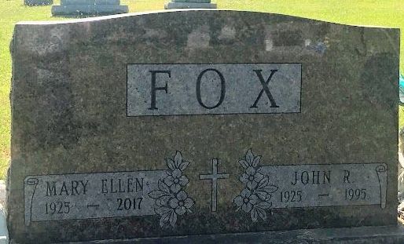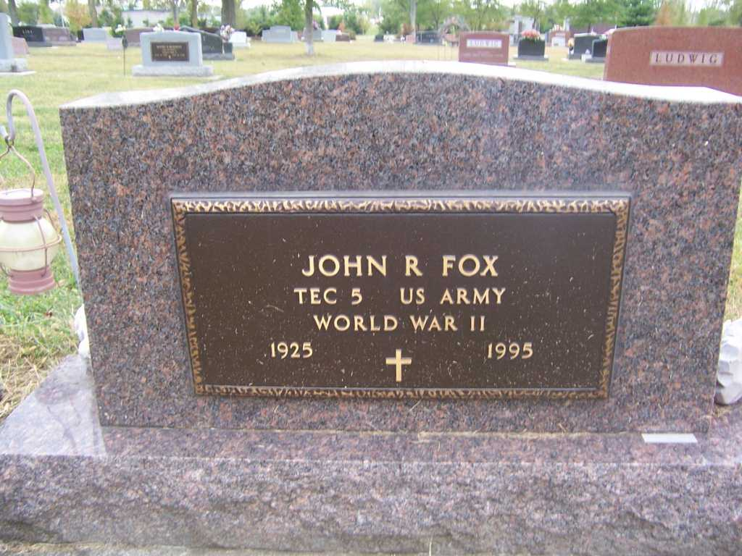
Photo by SMMR

Indiana, U.S., Death Certificates, 1899-2017
Name John R Fox
Gender Male
Race White
Marital Status Married
Age 69
Birth Date 3 Aug 1925
Birth Place Wells County, Indiana
Death Date 10 Jun 1995
Death Place Bluffton, Wells, Indiana, USA
Death Registration Date 1995
Father John W Fox
Mother Clara Kaves
Spouse Mary Ellen (Wible) Fox, informant
Burial 6-13-1995 Fairview

