Victor A. Foss
October 23, 1927 – December 10, 1979

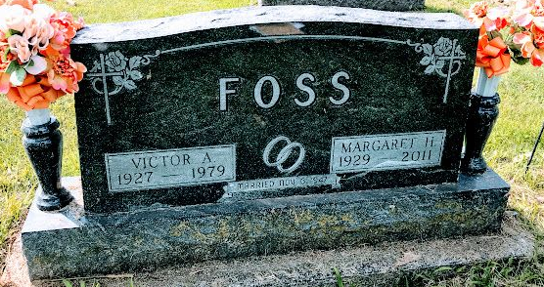
Photo SMMR
Indiana, U.S., Death Certificates, 1899-2017
Name Victor A. Foss
Gender Male
Race White
Marital Status Married
Age 52
Birth Date 23 Oct 1927
Birth Place Wisconsin
Death Date 10 Dec 1979
Death Place Bluffton, Wells, Indiana, USA
Death Registration Date 1979
Father Albert Foss
Mother Minnie Siebarth
Spouse Margaret (Stuhr) Foss, informant
Burial 12/12/1979 Fairview Cemetery

