Margaret Helen (Stuhr) Foss
April 16, 1929 – January 20, 2011

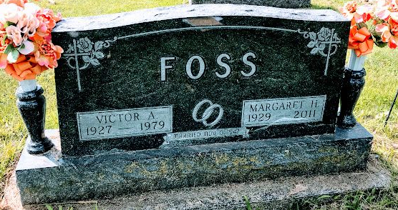
Photo SMMR
Margaret Helen Foss, 81, of Kendallville died Thursday, January 20, 2011, in Lutheran Life Villages, Kendallville. Mrs. Foss had resided in Kendallville for 13 years, coming from Bluffton. She retired after 25 years at the Caylor-Nickle Clinic in Bluffton. She had previously worked at the Wells Community Hospital in Bluffton for ten years.
She was a member of the Immaculate Conception Catholic Church in Kendallville. She enjoyed visiting the Senior Center, volunteering, camping, cooking, reading, and spending time with family.
She was born April 16, 1929, in Stratford, Wisconsin, to William and Mamie (Hopfensperger) Stuhr. On November 6, 1947, in Stratford, Wisconsin, she married Victor Foss, Sr.
Surviving are three sons, Roger Foss of Kendallville, Ronald Foss of Montpelier, and Victor Foss, Jr. and his fiancé, Amy Elkin of Kendallville; five grandchildren; five great grandchildren; 16 great grandchildren; and three sisters and a brother-in-law, Eleanor Bintzler of Paradise, California, Mildred Ermis of Saukville, Wisconsin, and Leona and Herbert Wachholz of Spencer, Wisconsin.
She was preceded in death by her parents, William and Mamie Stuhr; her husband, Victor Foss, Sr. in 1979; a son, Randall Foss; one sister; and two brothers.
Mass of Christian burial will be Tuesday, January 25, 2011, at 1:00 p.m. in Immaculate Conception Catholic Church, Kendallville, with Father James Stoyle officiating. Burial will be in Fairview Cemetery in Bluffton at 3:30 p.m.
Casketbearers will be Denny Foss, Cory Foss, Shawn Foss, Shane Foss, Clayton Foss, Justin Foss, and Skylar Elkin.
Calling is Monday, January 24, 2011, from 2 to 4 and 6 to 8 p.m. in Young Family Funeral Home, Kendallville Chapel, 222 South State Street, Kendallville where a prayer vigil will be held at 4:00 p.m.

Bluffton News-Banner, Wells County, Indiana
January 22, 2011

