Gladys Mae (Dubach) Fosnaugh
April 16, 1908 – September 13, 1963

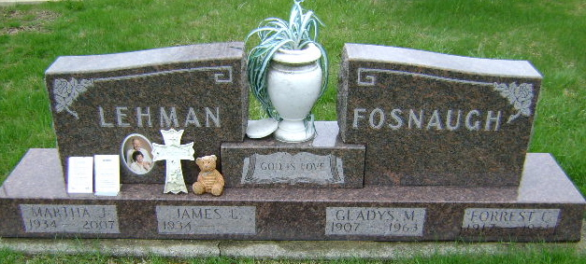
Photo by Bruce Sonner

Mrs. Gladys Fosnaugh, 55, wife of Forrest Fosnaugh, of Bluffton Route 3, died at 9:45 p.m. Friday while visiting at the home of her son, James Lehman of Bluffton. She had been ill 10 years due to a heart ailment.
A member of the Old Salem Evangelical United Brethren Church, Mrs. Fosnaugh formerly was employed by Decatur General Electric and Magnavox of Fort Wayne. She had resided in Wells County her entire life.
She was born April 16, 1908 in Nottingham Twp., the daughter of Charles and Lucinda Gottschalk Dubach. Her marriage to Forrest Fosnaugh took place Nov. 4, 1943 in Linn Grove.
Surviving, in addition to the husband and son, are five granddaughters.
The body is at the Yager Funeral Home in Berne, where friends may call after 2 p.m. Sunday. Services will be held at 10 a.m. Tuesday at the funeral home with Rev. Robert Bonewitz and Rev. Fuhrman Miller officiating. Burial will be in Fairview Cemetery.

Bluffton News-Banner, Wells County, Indiana
Saturday, September 14, 19963

