Forrest Charles Fosnaugh
September 19, 1917 – May 2, 1974

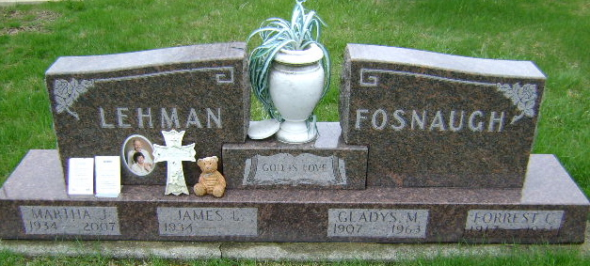
Photo by Bruce Sonner

Forrest Fosnaugh dies at Bluffton

Forrest C. Fosnaugh, 56, route 4, Bluffton, died at 9:50 p.m. Thursday in the Clinic hospital in Bluffton following a four-year illness.
Born in Wells county September 19, 1917, he was the son of Charles and Clara Johnson Fosnaugh. He was married in Adams county in 1939 to Gladys Mae Dubach, who died Sept 13, 1963.
A veteran of World War II, he retired in 1970 from the Tokheim Corporation in Fort Wayne. He was a member of the Park United Brethren Church.
Survivors include a stepson, James. L. Lehman, of route 4, Bluffton; five step-granddaughters, and two step-great-grandchildren; two sisters, Mrs. Anna L. Duke, Cumins, Mich.; Mrs. Oscar (Lorena) Andrews, route 3, Bluffton; two brothers, Donald Fosnaugh, of Geneva; Gartha Fosnaugh, Attica; and LaVern Fosnaugh, Springfield, Ill.
Friends may call after 7 p.m. this evening at the Goodwin Funeral Home in Bluffton. Funeral services will be conducted by the Rev. Gail Hirschy at 2 p.m. Sunday at the Goodwin Memorial Chapel in Bluffton. Burial will be at the Fairview cemetery at Bluffton.

Decatur Daily Democrat, Adams County, Indiana
Friday, May 3,1974
**

F. C. Fosnaugh, 56, Died; Ill 4 Years
Following an illness of four years, Forrest Charles Fosnaugh, 56, died at 9:50 p.m. Thursday at Clinic Hospital. Death was attributed to a cerebral hemorrhage. A resident of Bluffton Route 4 for the last eight years, he formerly made his home near Reiffsburg.
He was born Sept. 19, 1917 in Wells County, a son of Charles and Clara Johnson Fosnaugh. His marriage in 1939 in Adams county was to the former Gladys Mae Dubach, who precede him in death Sept. 13, 1963.
A member of the Park United Brethren Church, he was a veteran of World War II and retired in 1970 from Tokheim Corp. in Fort Wayne.
Surviving are a stepson, James Lehman of Bluffton Route 4; three brothers, Donald Fosnaugh of Geneva, Garth Fosnaugh of Attica and LaVerne Fosnaugh of Springfield, Ill.; two sisters, Mrs. Anna L. Duke of Gumins, Mich., and Mrs. Oscar (Lorena) Andrews of Bluffton Route 3; five step-granddaughters and two step-great-granddaughters
Friends may call after 7 p.m. today at Goodwin Memorial Chapel, where services in charge of Rev. Paul Hirschy are set for 2 p.m. Sunday. Burial will be in the Fairview Cemetery.

Bluffton News-Banner, Wells County, Indiana
Friday, May 3, 1974

