Washington Irving Fitch
May 25, 1841 – November 14, 1918

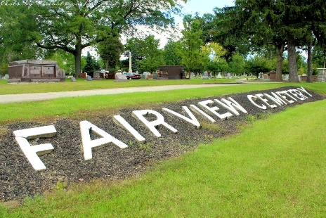
Photo by Tombstoner & Family

Funeral Services at Bluffton (Special to the News)

BLUFFTON, Ind., Nov. 18 – The body of W. I. Fitch, a former Bluffton factory owner, died last week in Las Vegas, N. M., and his body was brought here last night for burial. He was a member of the W. I. Fitch & Son, owners of the Bluffton Washing Machine factory. He left here about fifteen years ago, going to Warsaw. Surviving are the daughter Mrs. Charles Lewis, and Fred Fitch, of Warsaw.

The Fort Wayne Sentinel, Allen County, Indiana
Sunday, November 17, 1918
**

Indiana, U.S., Marriage Certificates, 1960-2012
Name Washington I Fitch
Gender Male; Race White; Marriage Age 70
Birth Date 25 May 1841; Birth Place Wayne, New York
Marriage License Date 11 May 1912
Marriage Date 12 May 1912; Marriage Place Kosciusko, Indiana, USA
Residence Place Warsaw, Kosciusko, Indiana
Father John O Fitch
Mother Sarah Hill
Spouse Eliza A Robinson
Officiator B H Truman
**

Washington Irvin Fitch from tree Jonathan's Family Tree
Birth 25 May 1841 Wolcott, Wayne, New York, USA
Residence 1910 Warsaw, Kosciusko, Indiana, USA
Marriage 12 May 1912 Warsaw, Kosciusko, Indiana, USA
Death 14 Nov 1918 Las Vegas, San Miguel, New Mexico, USA
Father John Otis Fitch (1812-1886)
Mother Matilda Darling (1815-1850)
Spouse Sarah Elizabeth McCaughan (1844-1905)
6365 People 10 Records 11 Sources

