Sarah (McCaughn) Fitch
November 12, 1844 – January 31, 1905

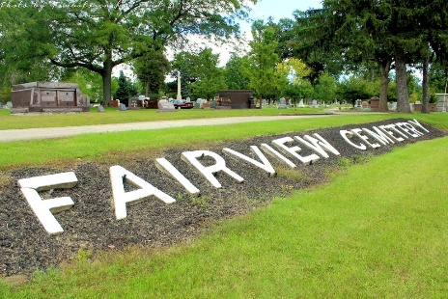
Photo by Tombstoner & Family

REMAINS TO LIE HERE
Body of Mrs. W. I. Fitch To Be Brought Here For Interment

Word was received in the city yesterday from Warsaw announcing the death of Mrs. W. I. Fitch, a sister of Mrs. Anna Brown of this city. Her death occurred at 5 o'clock and was the result of a sudden relapse. For several years she had been a sufferer from diabetes but her condition was not such as to cause her friends any immediate alarm.
However, she suffered a relapse Sunday, having taken a sudden cold, and her death occurred yesterday evening as announced. From the time she took sick Sunday, until her death, she failed rapidly.
Mrs. Fitch was well known in this city, having been a resident of Bluffton for a period of thirty-five years. She moved with her husband to Warsaw from this city only two years ago and has lived there ever since. Mrs. Fitch was a daughter of Mr. and Mrs. John McCaughn and was born in New York state. She moved here early in her life and in this city raised a family. She leaves two children and her husband to mourn her loss. The children are Fred Fitch, of Warsaw, and Mrs. Charles Lewis of New Mexico.
Arrangements were completed today for bringing the body to this city for interment. The remains will arrive here Friday at 11:58 and will be taken at once to the home of her sister, Mrs. Brown. The funeral will be held Saturday, the hour to be announced at a later date.

Bluffton Banner, Wells County, Indiana
Wed., Feb. 1, 1905
**

Indiana, U.S., Marriages, 1810-2001
Name Sarah E Mccaughn
Gender Female
Spouse W I Fitch
Child Annie C Fitch
**
Indiana, U.S., WPA Death Index, 1882-1920
Name Sarah E. Fitch
Date Jan 31, 1905
Location Warsaw
Age 60 Yr
Source location City Health Office, Warsaw
Source notes The source of this record is the book CH-2 on page 49 within the series produced by the Indiana Works Progress Administration.

