Berniece Diana (Patterson) Eubank
July 14, 1951 – November 12, 2023

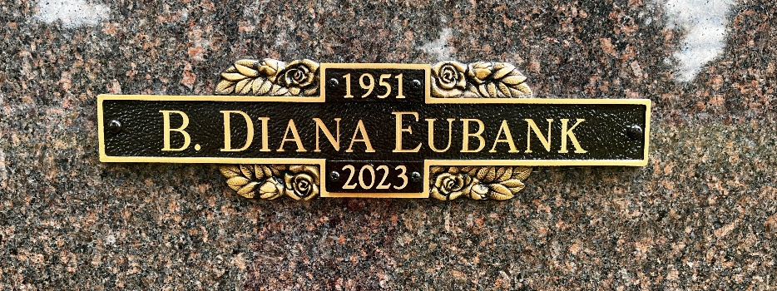
Photo by Sherry

Bernice Dianna Eubank, 72 of Markle, went home to the safety of her Lord and was reunited with her family and loved ones waiting for her on Sunday, November 12, 2023.
Dianna was born on July 14, 1951, in Bluffton to Joseph “Glenn” and Bertha E. (Fleming) Patterson. She graduated from Wabash High School in 1969. Dianna worked at Caylor-Nickel Clinic for 32 ½ years as a receptionist. She was a member of the Bluffton Church of God.
On June 22, 1996 in Bluffton, Dianna and Richard A. Eubank were married. They shared 22 years of marriage together until his passing on July 18, 2018.
Survivors include her children, Tiffanee Cole of Huntington and Joey “John Chaney” Patterson of Norway, MI., a stepson Jeffery A. (Lisa) Eubank, 7 grandchildren and 12 great-grandchildren. She is also survived by her siblings; Patsy Fields of Bluffton, Jack (Irene) Patterson of Harlan, KY, Candy (Ronald) Dougherty of Atwater, CA., and Linda Browning of Bluffton, along with many nieces and nephews.
She is preceded in death by her parents, her husband Richard, a son Thad Castleman and a stepdaughter, Jill M. Herndon.
Visitation will be held from 2 P.M. to 6 P.M. on Friday, (Nov. 24, 2023) at the Thoma/Rich, Lemler Funeral Home in Bluffton. Funeral services will take place at 10:30 A.M. on Saturday, (Nov. 25, 2023) at the funeral home with calling for one hour prior to the service, with Pastor John Roe officiating. Entombment will follow at the Northridge Community Mausoleum located at Fairview Cemetery.
Memorials may be made in Dianna’s memory to Ride to Provide through the funeral home.
Thoma/Rich, Lemler Funeral Home, Wells County, Indiana

