Kathryn Lois Engeler
September 26, 1916 – April 26, 1941

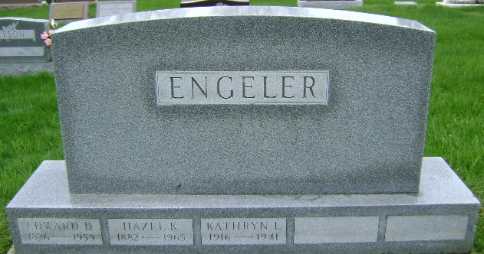
Photo by Bruce Sonner

FORMER LOCAL GIRL IS DEAD
Miss Kathryn Engeler Dies In California; Body Here Friday

Miss Kathryn Engeler, 24, daughter of Mr. and Mrs. E. D. Engeler, of this city died late Saturday afternoon at a Santa Barbara, California hospital, according to word received here.
The former well known and popular Decatur girl had been confined in the hospital for several days suffering from spinal meningitis and a pulmonary condition.
Miss Engeler was born in this city. She was graduated from the Decatur high school and after graduation was employed at the Edward’s studio here. She established a residence in California about two years ago.
Surviving, besides the parents, are three brothers, Gordon of Indianapolis, James of Cleveland Robert of Detroit.
The body is to leave California Tuesday by train and will arrive here Friday. Mr. and Mrs. Engeler will accompany the body. Funeral services have not been made known here.

Adams County (IN) Historical Museum
1941b Jan-Dec Scrapbook, image 012-016
Handwritten-April 26, 1941
**
Kathryn Engeler Funeral Sunday
The body of Kathryn Engeler, former Decatur young lady, will arrive here Friday afternoon at 2 o’clock on the Pennsylvania railroad.
Funeral services for Miss Kathryn Engeler, 24, former Decatur resident, who died April 26 at Santa Barbara, Calif., will be held at 3 o’clock (CDT) Sunday afternoon at the First Presbyterian church, Rev. George O. Walton officiating.
Private services for the family will be held earlier in the day at the Zwick funeral home, and the body will lie in state at the church after 1:30 o’clock Sunday afternoon. Burial will be in the Fairview cemetery at Bluffton.

Adams County (IN) Historical Museum
1941b Jan-Dec Scrapbook, image 017-020
Handwritten-May 4, 1941

