Hazel (Karns) Engeler
December 28, 1882 – April 19, 1965

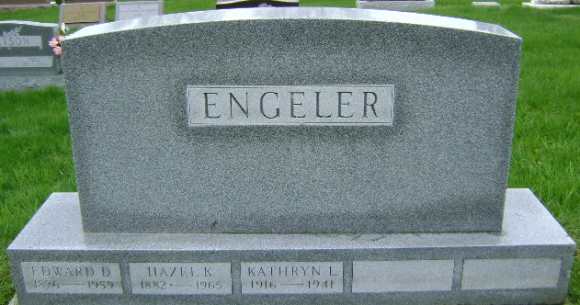
Photo by Bruce Sonner

Connecticut Death Index, 1949-2012
Name Hazel Engeler
Gender Female
Race White
Marital Status Widowed
Birth Date abt 1883
Residence Ridgefield, Fairfield, Connecticut
Death Date 19 Apr 1965
Death Place Ridgefield, Fairfield, Connecticut
Age 82 Years
Spouse Edwa
State File # 08438
**
U.S., Social Security Applications and Claims Index, 1936-2007
Name Hazel Karns Engeler [Hazel Karns Karns]
Gender Female
Birth Date 28 Dec 1882
Birth Place Bluhton Well, Indiana
Father Samuel M Karns
Mother Georgia A Thomas
SSN xxx
Notes Aug 1962: Name Listed As Hazel Karns Engeler
**
Hazel Karns from tree Wood Family Tree
Birth 28 Dec 1882 Bluffton, Wells, Indiana, USA
Marriage 31 Dec 1902 Wells, Indiana, USA
Residence 1960 Ridgefield, Fairfield, Connecticut, USA
Death 19 Apr 1965 Ridgefield, Fairfield, Connecticut, USA
Father Samuel Karns (1839-1901)
Mother Georgianne Thomas (1851-1923)
Spouse Edward D Engler (1876-1959)
1125 People 18 Records 27 Sources

