Edward Daniel Engeler
November 18, 1876 – January 9, 1959

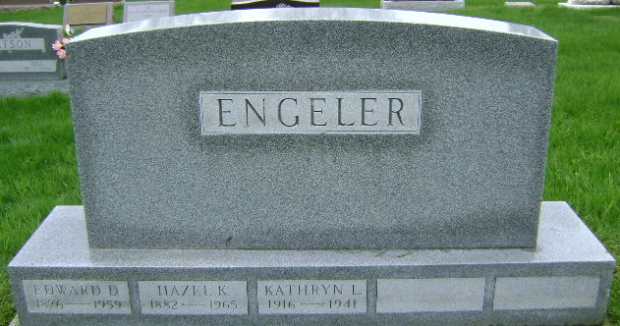
Photo by Bruce Sonner

Indiana, U.S., Death Certificates, 1899-2017
Name Edward D. Engeler
Gender Male
Race White
Marital Status Married
Age 82
Birth Date 18 Nov 1876
Birth Place Indiana
Death Date 9 Jan 1959
Death Place Decatur, Adams, Indiana, USA
Death Registration Date 1959
Father Frederick Engeler
Mother Rosanna Bieberstine
Informant Mrs. Hazel Engeler, wife
Burial 1-12-1959 Fairview Cemetery
**
Edward Daniel Engeler from tree DB Vitz Working Family Tree (00) (2025)
Birth 18 Nov 1876 Vera Cruz, Wells, Indiana, USA
Marriage 31 Dec 1902 Wells, Indiana, USA
Residence 3 Apr 1950 Decatur, Adams, Indiana, USA
Death 9 Jan 1959 Wells, Indiana, USA
Father Frederick Engeler (1831-1898)
Mother Rosanna Lena Biberstine (1840-1909)
Spouse Hazel Karns (1893-1965)
3220 People 13 Records 22 Sources

