Helen Arlene (Smith) Emshwiller
July 3, 1909 – July 18, 1991

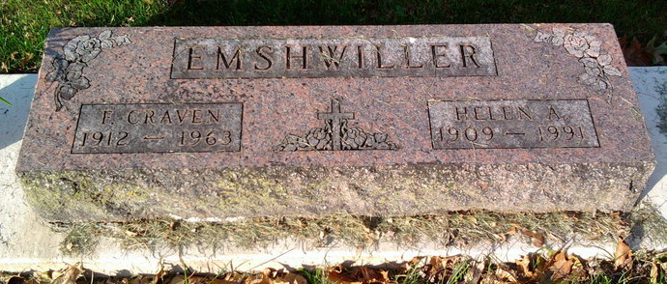
Photo by Thomas Liby

Indiana, U.S., Death Certificates, 1899-2017
Name Helen A Emshwiller
[Helen A Smith]
Gender Female
Race White
Marital Status Widowed
Age 82
Birth Date 3 Jul 1909
Birth Place Wells County, Indiana
Death Date 18 Jul 1991
Death Place Bluffton, Wells, Indiana, USA
Death Registration Date 1991
Father Joseph Smith
Mother Elva Ola Spaulding
Informant F. Joseph Emshwiller, son
Burial 7/21/1991 Fairview

