Fred Craven Emshwiller
May 14, 1912 – March 23, 1963

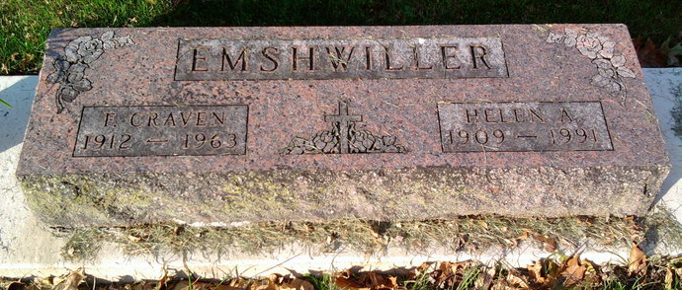
Photo by Thomas Liby

Craven Emshwiller Dies At Bluffton

Craven Emshwiller, 50, president of the Bluffton school board, and well known in Decatur, died at 8:30 o’clock Saturday night at the Wells county hospital following a brief illness.
He had been a member of the school board since 1956. He was formerly an internal revenue agent in this city, and later served as tax consultant for a number of Decatur business firms and individuals.
He served as lieutenant governor of the Lions club district in 1956, and was a member of the First Methodist church in Bluffton and the Scottish Rite at Fort Wayne.
Surviving are his wife, Helen; five children and one brother, Thomas Emshwiller, a former Decatur resident.
Funeral rites will be held at 1 p.m. Tuesday at the First Methodist church in Bluffton, with burial in Fairview cemetery. Friends may call at the Thomas funeral home until time of the services.

Berne (IN) Library Heritage Room
Adams County Obits 1962-1964, image 12
Monday, March 25, 1963
**

Indiana, U.S., Death Certificates, 1899-2017

Name Fred Craven Emshwiller
Gender Male
Race White
Marital Status Married
Age 50y 10m 9d
Birth Date 11 May 1912
Birth Place Montpelier, Indiana
Death Date 23 Mar 1963
Death Place Bluffton, Wells, Indiana, USA
Death Registration Date 1963
Father Fred O Emshwiller
Mother Inez Craven
Spouse Helen Emshwiller, informant
Burial 3-26-1963 Fairview Cemetery

