Tim Ray Ellis
September 15, 1950 – September 18, 1950

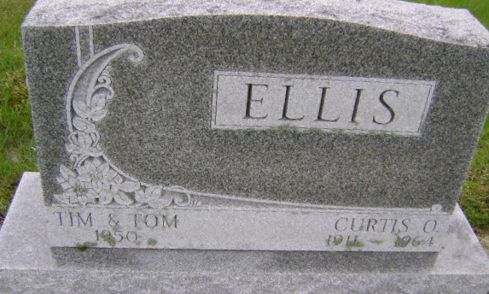
Photo by Bruce Sonner

Indiana, U.S., Death Certificates, 1899-2017
Name Tim Ray Ellis
Gender Male
Race White
Marital Status Single
Age 2d
Cause of death premature birth
Birth Date 15 Sep 1950
Birth Place Indiana
Death Date 18 Sep 1950
Death Place Bluffton, Wells, Indiana, USA
Death Registration Date 1950
Father Curtis O Ellis, informant
Mother Mary Pinney
Burial 9-19-1950 Fairview

