Mary (Pinney) Ellis
December 4, 1917 – July 16, 2017

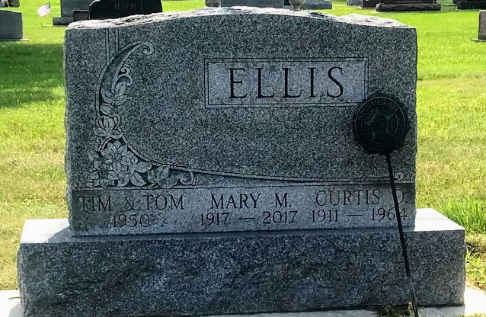
Photo by SMMR

Mary Ellis, 99, passed away on July 16, 2017 at River Terrace Estates in Bluffton.
Mary was born December 4, 1917 in Darke County, Ohio to Ernest and Lucy (Stout) Pinney. Her family moved to Mount Zion, Indiana in 1922. She graduated in 1935 from Chester Center High School, receiving her bachelor’s degree from Ball State in 1939 and her master’s degree from Saint Francis in 1966. She married Curtis O. (“Pete”) Ellis on July 24, 1940. He died in 1964.
Mary taught Home Economics in several area schools and retired as guidance counselor at Norwell High School.
She is survived by her children: Jill (Ben) Baughan of Mechanicsville, Virginia and Ted (Marge) Ellis of Bluffton. She is also survived by grandchildren: Jamie (Josh) Abercrombie of Cornelius, North Carolina; Rebecca (Martin Dessart) Ellis of Vienna, Austria; and Andrew Ellis of Bluffton; two step-grandchildren: Melissa (Matt) Reiff of Bluffton and Scott (Whitney) Saucedo of Carmel, Indiana; and ten great-grandchildren.
A Celebration of Life Service for Mary will be held at 10:30 A.M. on Wednesday, July 19, 2017, at the First Baptist Church in Bluffton. Pastor Les Cantrell will officiate. Burial will take place at Fairview Cemetery in Bluffton. Calling hours will be held from 2 to 8 on Tuesday at the Thoma/Rich, Lemler Funeral Home in Bluffton.
Preferred memorials are to the Turnaround Awards c/o The Wells County Foundation.

Thoma/Rich, Lemler Funeral Home, Wells County, Indiana
July 17, 2017

