Curtis Osman Ellis
May 9, 1911 – July 23, 1964

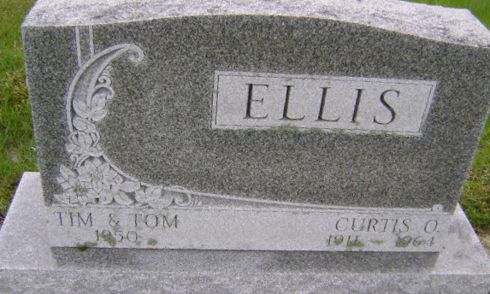
Photo by Bruce Sonner

Indiana, U.S., Death Certificates, 1899-2017
Name Curtis Osman Ellis
Gender Male
Race White
Marital Status Married
Age 53
Birth Date 9 May 1911
Birth Place Indiana
Death Date 23 Jul 1964
Death Place Bluffton, Wells, Indiana, USA
Death Registration Date 1964
Father Hiner H Ellis
Mother Lola M Garrett
Spouse Mary Ellis, informant
Burial 7-25-1964 Fairview Cemetery

