Julia (Brush) Ehler
May 14, 1866 – October 31, 1941

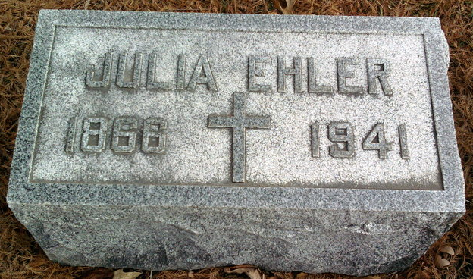
Photo by Thomas Liby

LOCAL MAN’S MOTHER DIES
Mrs. Julia Ehler Dies Suddenly At Bluffton Friday Night

Mrs. Julia Ehler, 75, mother of J. L. Ehler of this city, died suddenly at 11:15 o’clock Friday night at her home, 529 West Cherry street, Bluffton, of a heart attack suffered a few hours previously.
Mrs. Ehler was born May 14, 1866, in West Bloomfield, N. Y.; the daughter of Frederick and Ellen Bush. She married Jacob Ehler in 1885. He preceded her in death. The family had resided in Bluffton for the past 47 years. She was a member of the St. Joseph Catholic church and the St. Joseph altar society.
Surviving besides the son in this city are three other sons, Roy and Robert Ehler, both of Bluffton, and Charles C. Ehler of Huntington; three daughters, Miss Margaret Ehler, at home; Mrs. Fred Russel of Bluffton and Mrs. C. J. Murphy of Bluffton; two sisters, Mrs. Nell Baker of West Bloomfield, N. Y. and Mrs. George Howes of Ionia, N. Y., and 18 grandchildren. One son is deceased.
Funeral services will be held at the St. Joseph Catholic church in Bluffton Monday morning at 9 o’clock, Rev. Paul Anderson officiating. Burial will be in Fairview cemetery at Bluffton.

Adams County (IN) Historical Museum
1941b Jan-Dec Scrapbook, image 131
Handwritten-Thurs., Oct. 30, 1941
**

Indiana, U.S., Death Certificates, 1899-2017
Name Julia Ehler
[Julia Brush]
Gender Female
Race White
Marital Status Widow
Age 75y 5m 17d
Birth Date 14 May 1866
Birth Place West Bloomfield New York
Death Date 31 Oct 1941
Death Place Bluffton, Wells, Indiana, USA
Death Registration Date 1941
Father Fredrick Brush b. Germany
Mother Ellen Murphy b. Ireland
Spouse Jacob Ehler
Informant Roy Ehler, Bluffton, IN
Burial Fairview Cem. 11-3-1941

