Jacob Ehler
February 2, 1861 – April 16, 1917

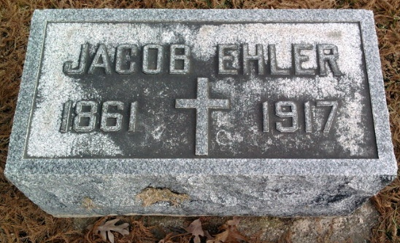
Photo by Thomas Liby

U.S., City Directories, 1822-1995
Name Jacob Ehler
Gender Male
Residence Year 1902
Street Address 210 East Arnold; Residence Place Bluffton, Indiana
Spouse Julia Ehler
Publication Title Bluffton, Indiana, City Directory, 1902
**
Indiana, U.S., WPA Death Index, 1882-1920
Name Jacob Ehler
Date Apr 16, 1917
Location Bluffton
Age 56 Yr
Gender Male
Race White
Source location City Health Office, Bluffton
Source notes The source of this record is the book CH-2 on page 88 within the series produced by the Indiana Works Progress Administration.
**
Jacob Ehler from tree McClain Family Tree
Birth 2 Feb 1861 Pennsylvania, USA
Marriage 29 Apr 1887
Residence 1910 Bluffton, Wells, Indiana, USA
Death 16 Apr 1917 Bluffton, Wells, Indiana, USA
Father Georg Johann Christian Ehlers (1812-1882)
Mother Sophia Wiseman (1827-1907)
Spouse Julia Busch (1866-1941)
13248 People 12 Records 24 Sources

