Sarah Jane (Boden) Drew
August 17, 1850 – February 14, 1882

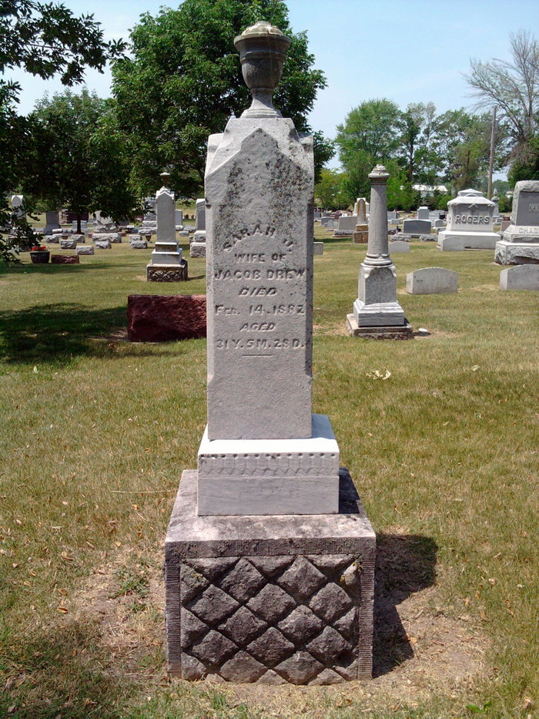

Died at their residence on Market street last Tuesday, the 14th day of Feb. 1882, Mrs. Sarah Jane (Boden) Drew, wife of Jacob Drew. The deceased was born in Bluffton, August 17th, 1850, being in her 32 year at the time of her death. She leaves a husband and two small children to mourn their loss. She is not (sic) at rest and her mourning friends have the sympathy of the entire community.

The Bluffton Banner, Wells County, Indiana
February 16, 1882, page 3, col. 6
**

Indiana, U.S., Select Marriages Index, 1748-1993
Name Sarah J. Boden
Marriage Date 18 May 1879
Spouse Jacob E. Drew
FHL Film Number 549313
Reference ID p 208

