PFC Merle C. Dick
May 5, 1921 – February 23, 1945

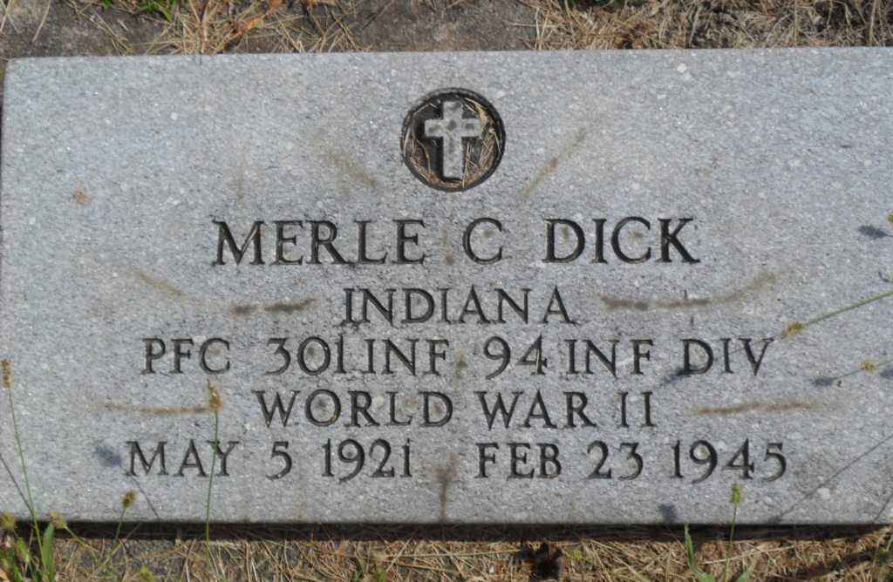
Photo by Pretty Little Grave Seekers

TWO COUNTY MEN KILLED IN ACTION
Pfc. Merle Dick Formerly of Geneva and Kruickeberg Youth Die

Adams county’s war casualty list was increased this week with the report of two soldiers killed in action, one in Germany and the other on Luzon Island in the Philippines.
Pfc. Merle C. Dick, 22, son of Mr. and Mrs. Carl Dick of Decatur, and until recently of Geneva, was killed in Germany February 23, with the infantry in Gen. Patton’s Third Army. He entered service in December, 1942, and was sent overseas last July.
He was born in Wells County, graduating from the Lancaster Central high school, and was employed by the Magnavox Company in Fort Wayne prior to entering service.
Surviving in addition to the parents are a brother, Pvt. Clarence V. Dick, a patient in an English hospital recovering from wounds sustained in Luxembourg January 20, and three sisters: Peggy Lou, Patty Ann and Nina Jane, all at home.
Pfc. Truman F. Krueckeberg, 25, son of Mr. and Mrs. Gus Krueckeberg of northeast of Decatur, was killed in Luzon February 15, where he was a member of the First Cavalry Division. A graduate of the Monmouth high school, he entered service January 19, 1942, and was sent overseas in July 1943. The parents, two brothers and four sisters survive.

Berne Witness, Adams County, Indiana
March 9, 1945
**

The body of Pfc. Merle C. Dick, who was killed in action in Germany on Feb. 23, 1945, will arrive at Decatur at 10:10 p.m. Tuesday and will be escorted to the home of the parents Mr. and Mrs. Carl C. Dick (address omitted) in Decatur, where it will remain until time for services.
Funeral services will be conducted at 2 p.m. Thursday at the Thoma funeral home here, with Rev. Harold Welty, pastor of the Decatur Missionary church, officiating. Burial will be in the Fairview cemetery. Members of Grover Sheets Post 111, American Legion, will conduct military rites.
Pfc. Dick was born in Bluffton on May 5, 1921, a son of Carl and Lucy Akers Dick. He was graduated in 1941 from the Lancaster Central high school and enlisted in the army on Dec. 19, 1942. The soldier was a member of the weapon platoon, company E, 301st infantry.
On Feb. 23, 1945, after his outfit successfully completed an attack on Tabeh, Germany, Pfc. Dick was killed instantly by fragments of an enemy artillery shell. His body was buried in an American cemetery at Duchy in Luxenburg.
Surviving in addition to the parents are a brother, Clarence Vernon Dick, of Decatur, and three sisters, Mrs. Peggy Lou Need, Fort Wayne, Mrs. Betty Ann Fox, of Decatur, and Nina Jane Dick, at home.

Bluffton News-Banner, Wells County, Indiana
Monday, April 18, 1949

