Nellie (McBride) Deam
January 8, 1863 – September 30, 1902

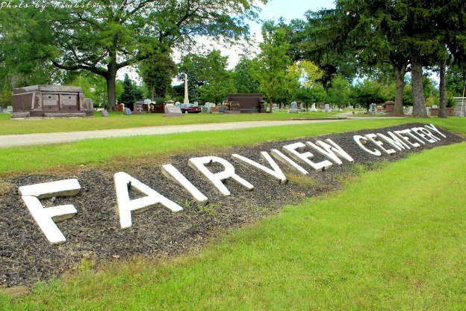
Photo by Tombstoner & Family

DEATH'S THIRD VISIT
Mrs. Herb H. Deam Follows Two Little Daughters to the Better World

Mrs. Herb H. Deam died at the home of her parents this morning at 11:40 after four days of terrible suffering. Her illness dated from the birth of a little daughter Saturday morning when she was taken with convulsions. Yesterday a hope for her recovery was entertained but today her condition was much worse.
Nellie McBride Deam was born on South Main street in this city January 8, 1863, and with the exception of four years spent in Kansas has lived in this city all her life. She was educated in the schools here, united with the Methodist church in childhood here and when she came to womanhood was united in marriage to Herb H. Deam on the 6th of October, 1885. Six children were born to them, only three of which are now living. The first to be taken away died in Sedgewick county, Kansas, and was sent here for burial. The death of Harriet, aged seven, occurred last Thursday, and Saturday morning the newly born baby died. Three daughters survive their mother, Mary aged 16, Bessie 10 and Helen 8.
As a young lady Mrs. Deam was popular in society circles, a leader in her class at school and when she became wife and mother her circle of friends was still increased and she was held in the highest esteem by all who knew her. Her married life was extremely happy until within the past few days when death laid such a heavy hand on the home, and the bereaved husband and children have the sympathy of every one who is acquainted with their bereavement.
The funeral will be conducted at the residence at 2:30 Thursday afternoon by Rev. L. A. Beek and Presiding Elder Daniels of the Methodist church and the remains will be interred in Fairview. Friends wishing to see the remains can do so on Thursday.

Evening News, Wells County, Indiana
Sept. 30, 1902
**

Indiana, U.S., Death Certificates, 1899-2017
Name [Mary Ellen Deam]
Maiden Name [McBride]
Gender Female
Race White
Marital Status Married
Age 39y 8m 22d
Birth Date 8 Jan 1863
Birth Place Indiana
Death Date 30 Sep 1902
Death Place Bluffton, Wells, Indiana, USA
Death Registration Date 1902
Father Warren Mc Bride
Mother Mary Miller
Spouse H H Deam
Informant Family
Burial Fairview Cem 10/2/1902

