Herbert Harlow Deam
May 25, 1862 – October 3, 1937

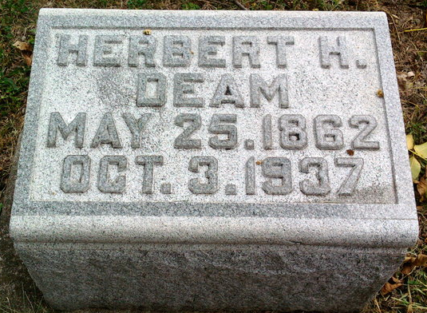
Photo by Thomas Liby

Herbert H Deam
in the Indiana, U.S., Death Certificates, 1899-2011
Name: Herbert H Deam
Gender: Male
Race: White
Age: 75
Marital status: Married
Birth Date: 25 May 1862
Birth Place: Bluffton, Indiana
Death Date: 3 Oct 1937
Death Place: Gary, Lake, Indiana, USA
Father: James Deam
Mother: Clara Barns
Spouse: Bertaline
Informant: Bertaline Deam
Burial: October 6, 1937; Bluffton Mausoleum
Mother Mary Miller
Spouse H H Deam
Informant Family
Burial Fairview Cem 10/2/1902

