Bertaline (Mason) Deam
March 27, 1879 – December 29, 1953

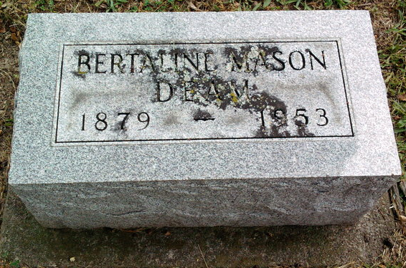
Photo by Thomas Liby

Indiana, U.S., Death Certificates, 1899-2017
Name Bertaline Mason Deam
[Bertaline Mason Mason]
Gender Female
Race White
Marital Status Widowed
Age 74
Birth Date 27 Mar 1879
Birth Place Indiana
Death Date 29 Dec 1953
Death Place Gary, Lake, Indiana, USA
Death Registration Date 1953
Father William Mason
Mother Mary E Adams
Informant Mrs. Milo Vale
Burial Fairview Cem. 12/31/1953
**
Indiana, U.S., Marriages, 1810-2001
Name Bertaline Mason
Gender Female
Event Type Marriage Registration (Marriage)
Marriage Date 12 Oct 1904
Marriage Place Indiana, United States
Spouse Herbert H Deam
Page 348
FHL Film Number 002318464

