May (Sweeny) DeRuyscher
September 4, 1895 – June 8, 1979

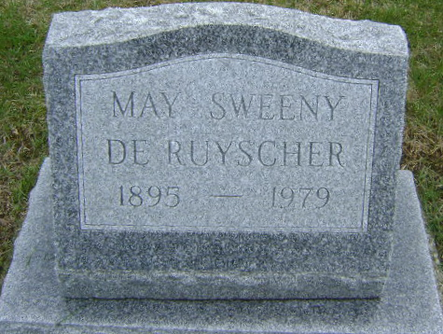
Photo by Bruce Sonner

Mrs. DeRuyscher Dies at Age 83
Ill several years, Mrs. May Sweeny DeRuyscher, 83, died at 4:30 a. m. today at Cooper Rest Home. Born Sept. 4, 1895 in Wells County, she was the daughter of Willit C. and Ida Sowards Sweeny.
Surviving are two daughters, Mrs. Roscoe (Ruth E.) Wall of Bluffton and Mrs. Charles (Mary Lois) Nelson of Muncie; a brother, Robert J. Sweeny of Bluffton; a sister, Mrs. Garth (Nellie) Double of Fort Wayne, eight grandchildren and three great-grandchildren.
Calling will be after 7 p.m. today at Goodwin Memorial Chapel with services there at 2:30 p.m. Saturday in charge of Rev. Edwin Willett. Burial will be in Fairview Cemetery.

Bluffton News-Banner, Wells County, Indiana
Friday, June 8, 1979, p. 3, c. 8

