Freida M. (Lydy) DeBolt
January 26, 1928 – September 5, 2018

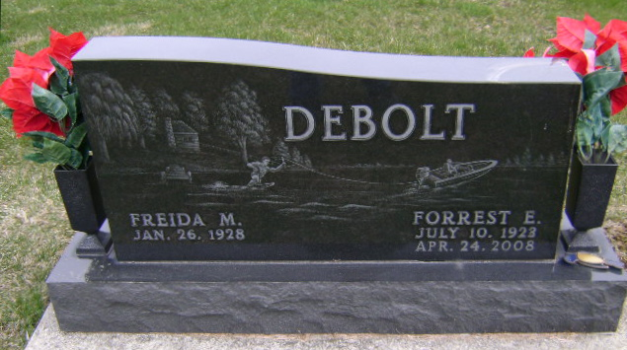
Photo by Bruce Sonner

Freida M. DeBolt, 90, of Bluffton passed away early Wednesday morning, September 5, 2018, at River Terrace Estates in Bluffton.
Freida was born on January 26, 1928 in Wells County, Indiana to Charles W. & Leota (Roll) Lydy. A lifelong resident, Freida graduated from Liberty Center High School in 1946. She worked as a supervisor at Magnavox in Fort Wayne for 42 years, retiring in 1990. She was a member of Calvary Lutheran Church in Bluffton. On October 12, 1946 in Fort Wayne, Freida and Forrest E. DeBolt were married. They shared 62 years of marriage before he preceded her in death on April 24, 2008.
Survivors include two daughters; Pennie Jones and Debra Smith of Bluffton, along with 3 grandchildren; Craig Harrold, Stacy Richards and Lesley McDougal, along with 7 great-grandchildren.
She is preceded in death by 3 sisters, 3 brothers and a granddaughter, Kari Harrold.
A service to celebrate Freida’s life will be held at 10:30 A.M. on Saturday (September 8, 2018) at the Thoma/Rich, Lemler Funeral Home in Bluffton. Burial will follow at Fairview Cemetery. Calling hours will be held from 4 to 8 P.M. on Friday and for one hour prior to the service on Saturday.
Memorials may be made to Calvary Lutheran Church.
Thoma/Rich Funeral Home, Wells County, Indiana
September 5, 2018

