Forrest E. DeBolt
July 10, 1923 – April 24, 2008

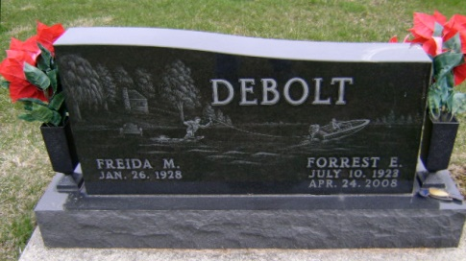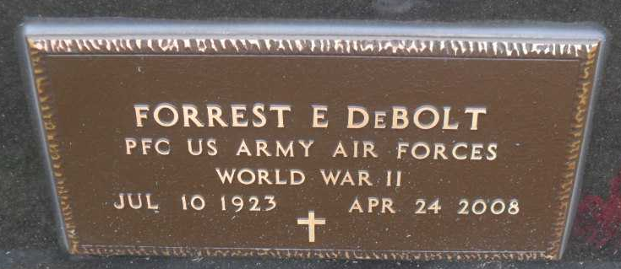
Photo by Bruce Sonner & Pretty Little Grave Seekers

Forrest E. “Frosty” DeBolt, 84, of Bluffton, died at 8:18 p.m. Thursday, April 24, 2008, at Lutheran Hospital in Fort Wayne. Born in Adams County on July 10, 1923 to Chancey and Estella (Tinkham) DeBolt, he married Freida M. Lydy in Fort Wayne on Oct. 12, 1946; she survives.
Mr. DeBolt attended Monmouth High School and furthered his education with courses at I.U.P.U. He served in the U.S. Air Force during World War II, attached to the 483rd bomber group, and was a member of American Legion Post #111. He was a supervisor at Franklin Electric for 35 years, retiring in 1981. He was also a member of the Eastern Woodland Carvers Club and Calvary Lutheran Church.
Other surviving relatives include two daughters, Pennie (Bryan) Jones of Troy, Kans., and Debra Smith of Bluffton; three grandchildren and seven great grandchildren. Mr. DeBolt was also preceded in death by two brothers, Lloyd and Paul DeBolt, and two sisters, Florence Bowman and Grace Swoveland.
Funeral services will be at 10:30 a.m. Monday, at the Thoma/Rich, Chaney & Lemler Funeral Home in Bluffton with Pastor Gene Kinney officiating. Calling hours will be from 2 to 8 p.m. Sunday and one hour prior to the service at the funeral home. Burial is at Fairview Cemetery, in Bluffton, with military graveside rites by American Legion Post #111 and the U.S. Air Force Honor Guard. Preferred memorials are to Calvary Lutheran Church.

Thoma/Rich Funeral Home, Wells County, Indiana
April 25, 2006

