Norman J. Dailey
October 6, 1946 - October 8, 2017

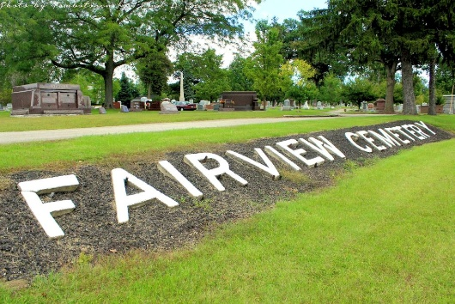
Photo by Tombstoner & Family

Norman J. Dailey, 71, of Ossian, passed away on Sunday afternoon, October 8, 2017, at his residence surround by his family.
He was born on October 6, 1946 in Fort Wayne to Paul W. & C. Corrinne (Costello) Dailey. Norman graduated from South Side High School in Fort Wayne and went on to earn a degree in Christian education from Fort Wayne Bible College. He worked at Zollner Piston Corp. in Fort Wayne for 32 years and has worked for the Wal-Mart in Bluffton and Decatur over the past 5 years.
Norman had a sincere heart for the Lord, and enjoyed his trip he took to Israel. He was an active member of Hope Missionary Church for over 30 years. Next to his faith, he was a very proud father that supported his daughters in any way that he could and was a very loving grandpa. He enjoyed history antiques and restoring his home, that has been in the family for many generations.
On June 15, 1975 in Warren, Norman and Rose M. (Drabenstot) were married.
He is survived by his wife Rose of Ossian along with two daughters: Sarah Rose Dailey of Bluffton and Lydia Jessie (Jarrod) Kunkel of Bluffton along with six grandchildren. Norman was the youngest of three boys, and is also survived by his brothers Paul W. (Diane) Dailey of St. Charles, IL and Richard A. (Nancy) Dailey of Fountain Hills, AZ., along with many cousins.
Funeral Service for Norman will be held at 10:30 A.M. on Wednesday (Oct. 11, 2017) at the Thoma/Rich, Lemler Funeral Home in Bluffton. Pastor Gary Aupperle will officiate. Calling hours will take place from 4 to 8 P.M. on Tuesday at the funeral home and for one hour prior to the service. Burial will follow at Fairview Cemetery in Bluffton.
Memorials may be made to Hope Missionary Church in his memory.
Thoma/Rich, Lemler Funeral Home, Wells County, Indiana
October 9, 2017

