David Frank Curry
1855 – September 16, 1910

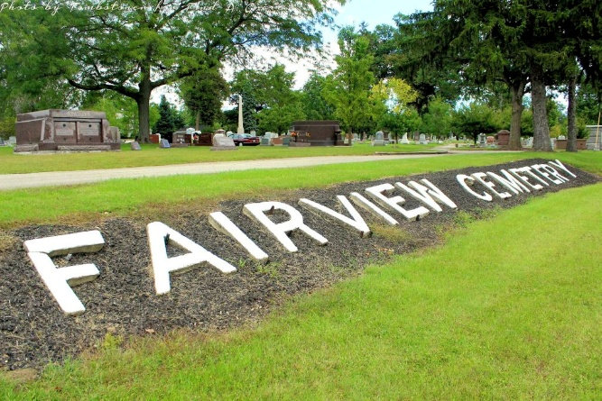
Photo by Tombstoner & Family

Frank Curry, aged fifty-five, a rich old widower of Bluffton, whose wealth is estimated at $75,000, was killed at Fort Wayne Friday night, when he was struck by a Pennsylvania train. His body was found by a tramp, who reported to the trainmen, and he was not identified until Saturday morning. Curry was a heavy drinker. He lived practically alone and went to Huntington Thursday to attend the fair, going from there to Fort Wayne.

Berne Witness, Adams County, Indiana
Tuesday, Sept. 20, 1910
**

Indiana, U.S., Death Certificates, 1899-2017
Name Frank Curry
Gender Male
Race White
Marital Status Divorced
Age about 58 yrs
Birth Date abt 1852
Birth Place Indiana
Death Date 16 Sep 1910
Death Place Fort Wayne, Allen, Indiana, USA
Death Registration Date 1910
Father Amos Curry
Mother Elizabeth Studebaker
Informant D. C. Vaughn, Bluffton, IN
Burial Fairview Cem unreadable date
**
Indiana, U.S., Marriages, 1810-2001
Name David Frank Curry
Gender Male
Race White
Event Type Marriage Registration (Marriage)
Birth Place Markle, Huntington
Marriage Date 21 May 1897
Marriage Place Bluffton, Indiana, United States
Residence Place Bluffton
Father Amos Curry
Mother Elizabeth Studabaker
Spouse Minnie Johnson
Page 256

