William Sylvester Crouse
September 18, 1845 – January 26, 1920

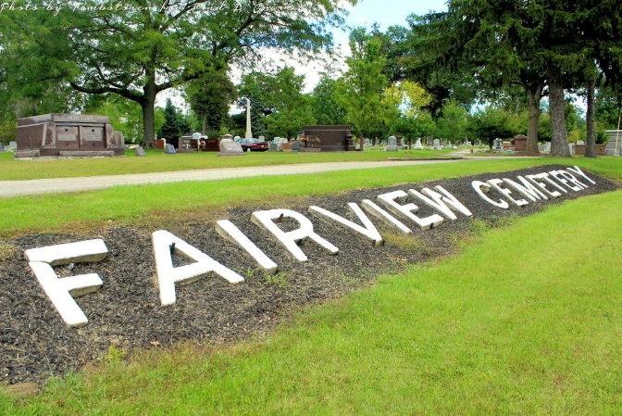
Photo by Tombstoner & Family

CROUSE

Bluffton, Ind., Jan. 26 – William S. Crouse, 74, a well-known local Civil War veteran, died at 1 o’clock this afternoon at his home at 880 South Mulberry Street, this city, from kidney trouble. An operation a few days ago failed to give relief.
Children surviving are Mrs. John J. Miller, Mrs. Benjamin Kapp, Mrs. Robert Stout, Mrs. J. H. Dillon and Carmon Crouse.
He belonged to the Lew Dailey Post G.A.R. here and to the local lodge of Red Men.
Funeral services will be held Thursday afternoon at 3 o’clock at the Baptist church and burial will be in Fairview Cemetery.

Journal-Gazette, Allen County, Indiana
January 27, 1920, Page 14
**

Indiana, U.S., Death Certificates, 1899-2017
Name William Sylvester Crouse
Gender Male
Race White
Marital Status Widowed
Age 74y 9m 8d
Birth Date 18 Sep 1845
Birth Place Delphi, Ohio
Death Date 26 Jan 1920
Death Place Bluffton, Wells, Indiana, USA
Spouse Mary L. Crouse
Parents unknown
Informant John Viller, Bluffton, IN.
Burial Fairview 1/29/1920
**
U.S., Veterans Administration Master Index, 1917-1940
Name William S Crouse
Record Type Military Service
Birth Date 18 Sep 1845
Military Date 27 Aug 1864
Residence Place Bluffton, Indiana
Death Date 26 Jan 1920

