Hillard Costello
December 5, 1900 – October 21, 1936

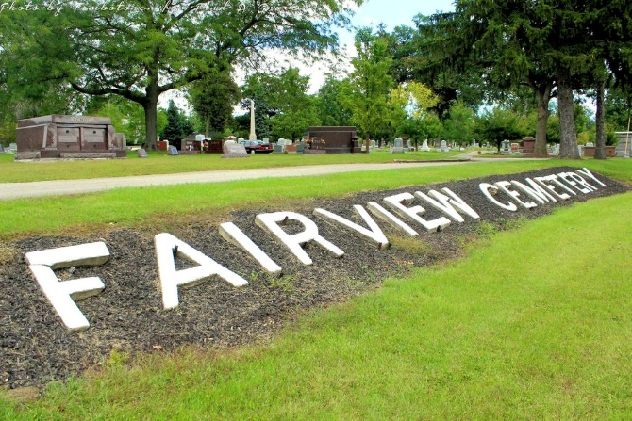
Photo by Tombstoner & Family

COSTELLO

Bluffton, Oct. 22 - Hillard Costello, 35, former resident of Bluffton, died at the State Hospital at Richmond and the body was returned here for funeral services at the Thoma Funeral Home at 2 pm Friday. Burial will be in Fairview Cemetery here.
His parents, Mr. and Mrs. Edward Costello and a brother and sister preceded him in death.

Fort Wayne Journal-Gazette (Allen County, Indiana)
October 23, 1936, Page 10
**

HILLARD COSTELLO CALLED BY DEATH
Former Bluffton Resident Dies Wednesday
Funeral Friday P. M.

The body of Hillard Costello, 35, former Bluffton resident, has been returned to the Thoma funeral home in this city from the state hospital at Richmond, where his death occurred Wednesday.
He was born in Bluffton on Dec. 5, 1900, a son of Edward and Nellie Confer Costello. His parents, a brother, Brooks, and a sister, Fern, all preceded him in death.
Funeral services will be held at 2:30 p.m. Friday at the Thoma funeral home in charge of the Rev. Thomas Ballard. Burial will be in Fairview cemetery.

Evening News Banner, Wells County, Indiana
Thursday, October 22, 1936, p. 1, c. 4

