Florence K. (Kocher) Copeland
October 17, 1860 – February 12, 1940

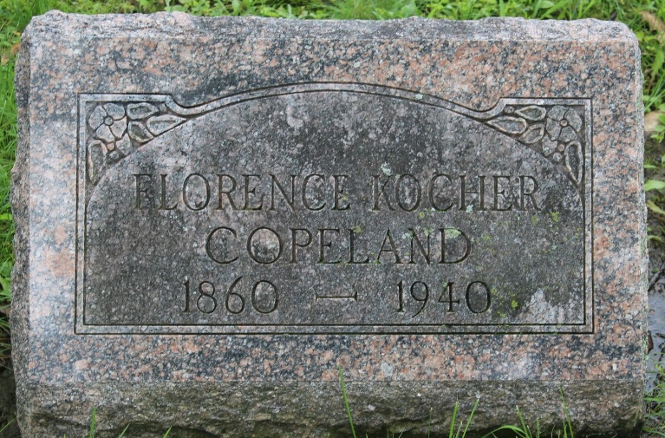
Photo by Tombstoner & Family

COPELAND

Bluffton, Feb. 13 – Word was received here today of the death of Mrs. Florence Kocher Copeland, 70, a former resident of Bluffton, at Miami, Fla., of a heart attack.
She had been making her home with a brother, George Kocher, and his wife, at Elida, O., and had gone to Florida for the winter. She taught in the Bluffton schools as a young woman, later locating in Indianapolis.
Surviving is another brother, James T. Kocher of Decatur.
The body will be returned here to the funeral home of H. Thoma & Son, and funeral services will be held there at 2 pm Sunday, in charge of Rev. W. J. Lichau of the Presbyterian Church. Burial will be in Fairview Cemetery.

Journal-Gazette, Allen County, Indiana
February 14, 1940
**

Bluffton, Feb. 15 – The body of Mrs. Florence Kocher Copeland, a former resident here, who died Monday at Miami, Fla., arrived here today and will be at the funeral home of M. Thoma & Son, where funeral services will be held at 2 pm Sunday. Burial will be in Fairview Cemetery here.

Journal-Gazette, Allen County, Indiana
February 16, 1940
**

Florence Korelia Kocher from tree Cocciolo Family Tree
Birth 17 Oct 1860 Ohio, USA
Residence 1895 Indianapolis, Marion, Indiana, USA
Marriage 28 Jun 1911 Delaware, Indiana, USA
Death 12 Feb 1940
Father George Thomas Kocher (1828-1918)
Mother Nancy Helen Rea (1840-1922)
Spouse Herbert F Copeland
96 People 6 Records 8 Sources
**
Indiana, U.S., Marriage Index, 1800-1941
Name Florence K Kocher
Marriage Date 28 Jun 1911
Marriage Place Delaware, Indiana, USA
Spouse Name Herbert F Copeland
**
U.S., Newspapers.com™ Obituary Index, 1800s-current
Name Florence K Copeland
Gender Female
Death Age 78
Birth Date abt 1862
Residence Place Bluffton, Wells, Indiana, USA
Death Date Abt 1940
Death Place Miami, Indiana, USA
Obituary Date 14 Feb 1940
Obituary Place Miami, Florida, USA
Newspaper Title The Miami Herald
Siblings George T Kocher, J L Kocher

