William E. Conner
August 27, 1923 – December 22, 2003

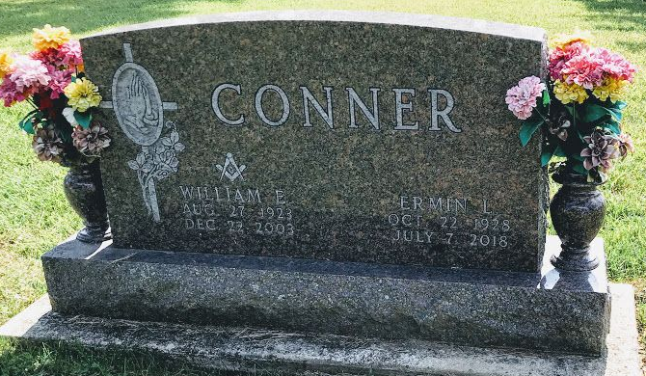
Photo by SMMR

Funeral services for Mr. William E. "Ed" Conner, 80, of Bluffton, IN, were conducted at 10 a.m. Saturday, December 27, 2003, at Epworth United Methodist Church in Bluffton. Burial was in Fairview Cemetery. with Pastor Don Wilks officiating.
Mr. Conner died Monday, December 22 at home. He was a member of Canton Masonic Lodge 481 and Epworth United Methodist Church. He moved to Bluffton in 1951, and worked at Sterling Casting Company from 1951 until he retired in 1987 with 36 years of service. After his retirement, he served six years as a custodian at Epworth United Methodist Church, and he assisted with Bible school at the church for several years. Mr. Conner was also a den leader with the Cub Scouts and Boy Scouts.
Born August 27, 1923, in Overton County, he was the son of the late William and Ellen (Sullivan) Conner. In addition to his parents, he was preceded in death by a daughter, Linda Sue Conner; and a sister, Nannie Conner.
Survivors include his wife, Ermin L. (Hummel) Conner; two sons, Terry E. Conner of Ft. Wayne, IN, and Timothy L. Conner of Delphi, IN; two grandsons, Spencer Conner and Alex Conner; and a granddaughter, Molly E. Conner.
Memorial donations may be made to Epworth United Methodist Church.

Thoma/Rich, Lemler Funeral Home, Wells County, Indiana

