Patricia L. (Grove) Conner
July 1, 1927 – August 11, 2017

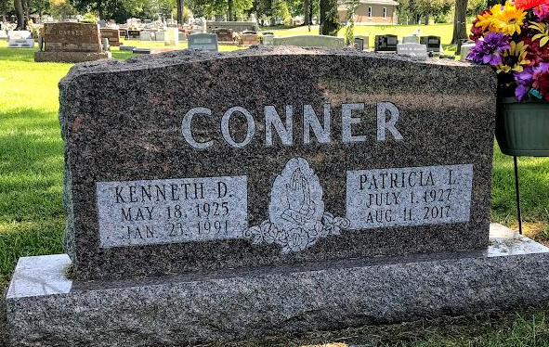
Photo by SMMR

Patricia L. Conner 90, of Bluffton passed away on Friday morning, August 11, 2017, at Christian Care Retirement Community in Bluffton.
Pat was born on July 1, 1927 in Fort Wayne to Russell D. & Ruth V. (Henkel) Grove. She graduated from Bluffton High School in 1945. She worked as a floral designer for the former Wabash Avenue Greenhouse for 22 years and co-owned & operated the Posy Pot Florist with Marijane Bossert for 10 years, retiring in 1992.
She was a member of the First Church of Christ, where Pat was very active with the Helping Hands, Vacation Bible School where she was known as the “Cookie Lady” and served as an interpreter for the Smith family for Sunday morning services. She also volunteered with the Wells County Food Bank.
On March 9, 1947 in Bluffton, Pat and Kenneth D. Conner were married. He preceded her in death on January 23, 1991.
Survivors include her daughter Cheryl (Craig) Mann of Bluffton, along with six grandchildren: Jeff (Tonya) Thompson, Jami (Tim) Prough, Jennifer (Chris) Earhart, David (Denise) Conner, April Wimmer and Tim (Malisa) Conner along with 15 great-grandchildren and 6 great-great-grandchildren. Pat is also survived by a step-granddaughter Melissa (Nathan) Huss and 4 step-grandchildren.
Pat is preceded in death by a son Michael Wayne Conner, a son-in-law William G. Thompson, a great-granddaughter Abigail Conner and a brother Richard F. Grove.
A service to celebrate Pat’s life will be held at 10:30 on Tuesday (August 15, 2017) at the First Church of Christ. Jeff Lemler will officiate. Calling hours will take place on Monday (August 14, 2017) from 2 to 8 p.m. at the Thoma/Rich, Lemler Funeral Home in Bluffton, and for one hour prior to the service on Tuesday at the church. Burial will follow at Fairview Cemetery in Bluffton.
Memorials may be made in Pat’s memory to the First Church of Christ.

Thoma/Rich, Lemler Funeral Home, Wells County, Indiana
August 12, 2017

