Kenneth D. Conner
May 18, 1925 – January 23, 1991

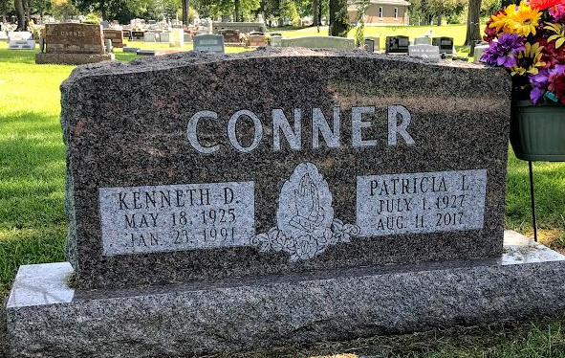
Photo by SMMR

Indiana, U.S., Death Certificates, 1899-2017
Name Kenneth D Conner
Gender Male
Race White
Marital Status Married
Age 65
Birth Date 18 May 1925
Birth Place Bluffton
Death Date 23 Jan 1991
Death Place Bluffton, Wells, Indiana, USA
Death Registration Date 1991
Father B Frank Conner
Mother Veda Masterson
Spouse Patricia (Grove) Conner, informant
Burial 1/26/1991 Fairview

