Ermin L. “Erma” (Hummel) Conner
October 22, 1928 – July 7, 2018

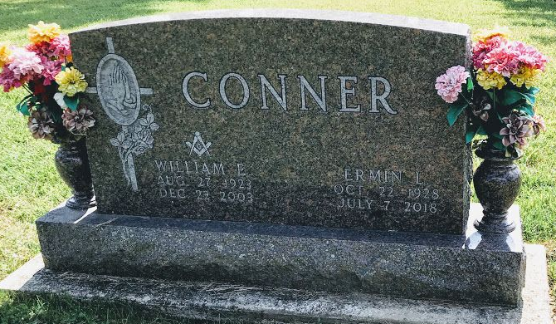
Photo by SMMR

Erma L. Conner, 89, of Bluffton passed away early Saturday morning, July 7, 2018, at Christian Care Retirement Community in Bluffton.
Erma was born on October 22, 1928 in Clay County, TN to Orville & Nora (Melton) Hummel. She attended Fairview High School and on January 28, 1950, married William E. “Ed” Conner in Livingston, TN. Together, they moved to Bluffton in 1951.
Erma worked at the Wells Community Hospital for 13 years, where she was the head of the surgical Instruments Department and retired in 1985. She was a member of Epworth United Methodist Church, where she served on the board of trustees and was an active member of U.M.W, United Methodist Women. Erma also served as a den mother for the Cub Scouts and enjoyed quilting, crocheting, tending to her flowers and traveling in her free time.
Erma is survived by two sons; Terry (Kathy) Conner of Fort Wayne and Timothy L. (Sheryl) Conner of Delphi, along with three grandchildren; Spencer Conner, Alex Conner and Molly Conner.
She is preceded in death by her parents, her husband Ed, a daughter Linda Sue Conner, two brothers Edward & Elmer Hummel and a sister Ardel Hummel.
A service to celebrate Erma’s life will be held at 10:30 A.M. on Wednesday (July 11, 2018) at Epworth United Methodist Church in Bluffton with Pastor Marlene Ellis and Tony Garton officiating. Calling Hours will be held from 2 to 4 & 6 to 8 on Tuesday at the funeral home and for one hour prior to the service at the church.
Burial will follow at Fairview Cemetery in Bluffton.
Memorials may be made to Epworth United Methodist Church Trustee Fund.
Thoma/Rich, Lemler Funeral Home, Wells County, Indiana
July 8, 2018

