Jennifer K. (Hess) Collins
July 18, 1970 – July 19, 2017

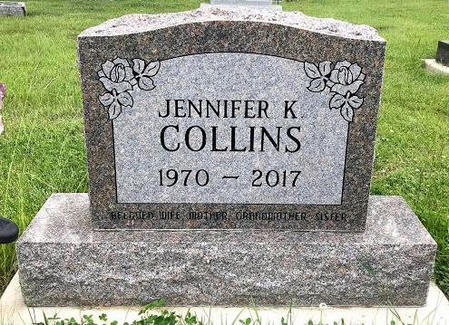
Photo by SMMR

Jennifer K. Collins, 47, of Elizabethtown, KY, passed away at her sister’s residence in Berne, IN on Wednesday, July 19, 2017. She was born on July 18, 1970 to the late Waymon Hess and Judy (Smeltzer) Kendrick in Decatur, Indiana. On July 17, 1999 she married James M. Collins.
She served her country in the United States Navy. Jennifer had a Master’s Degree in Professional Counseling and a Bachelor’s Degree in Psychology. She worked as a Caregiver.
Jennifer is survived by her husband of 18 years, James “Mike” Collins of Elizabethtown, KY; mother, Judy Kendrick of Geneva, IN; her adoptive parents, Kenneth and Mary Ann Love of Eaton, IN; two sons, Alexander (Amanda) Loy of Rineyville, KY and Robert (Kayla) Loy of Elizabethtown, KY; one brother, Christopher Love of Ft. Campbell, KY, a sister, Paula (Jimmie Miranda) Beck of Berne, IN and three grandchildren, Branden Loy, Austin Loy, and Brooklyn Loy.
She was preceded in death by a grandson, Christopher Loy, biological father, Waymon Hess, and maternal grandmother, Isabelle Smeltzer.
A Private Family visitation will be held on Monday, July 24, 2017 at the Haggard-Sefton & Hirschy Funeral Home. Burial will take place at the Fairview Cemetery in Bluffton, IN on Tuesday, July 25, 2017.
Memorials may be made to the Family.

Haggard-Sefton & Hirschy Funeral Home, Adams County, Indiana
July 20, 2017

