Ronald J. Coffield
September 23, 1934 – January 20, 2023

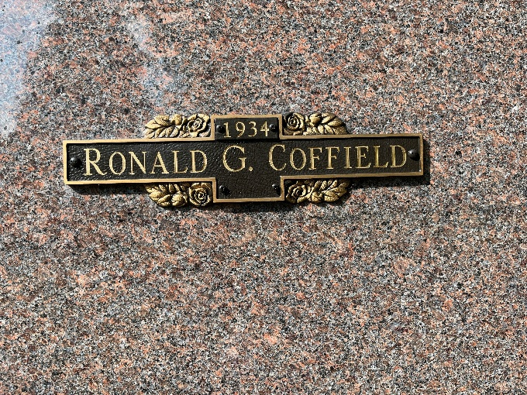
Photo by SMMR

Ronald G. Coffield, 88, of Bluffton, IN, passed away peacefully at his home with his family at his side on Friday, January 20, 2023. He was born on Sunday, September 23, 1934, in Bluffton, IN. He married Roberta J. Crockett on September 8, 1957 in Bluffton; she precedes him in death on April 24, 2014.
Ronald attended Bluffton High School. He served his country in the US Navy. Ronald owned and operated his truck and was a long-haul driver. He was an honorary adopted grandpa to many. He was a member of the Teamsters Union Local 414, Grover Sheets American Legion Post # 111, Bluffton, IN, and the V.F.W. Ronald wintered for many years at Gulf Shores Alabama and enjoyed golfing and gardening.
Ronald will be sadly missed by his daughter- Sheila (Mike Malnor) Soto, Ft. Wayne, IN, sons- Rod (Melissa) Coffield, Senoia, GA, Bert (Amy) Coffield, Ossian, IN, companion - Ann Wedding, Bluffton, IN, several nieces & nephews, sister-in-law - Dortha Teague, Hartford City, IN, sister-in-law - Mary Coffield, Bluffton, IN, 10 grandchildren, and 20 great grandchildren.
He was preceded in death by his wife- Roberta J. (Crockett) Coffield, father - Clyde Allen Coffield, mother - Emma Gertrude (Fryback) Coffield, brother - Rex Coffield, and sister - Betty Sawyer.
Family and friends may gather to share and remember at Walker & Glancy Funeral Home 109 W Windsor St Montpelier on Friday, January 27, 2023 from 2:00 PM to 8:00 PM and from 10:00 AM to 11:00 AM on Saturday, January 28, 2023. A service to celebrate Ronald’s life will be at Walker & Glancy Funeral Home at 11:00 AM on Saturday, January 28, 2023 with Pastor Steve Rogers officiating. Entombment will follow in the Fairview Cemetery in Bluffton. Military rites will be conducted by the US Navy and Grover Sheets American Legion.
Preferred memorials: Wounded Warrior Project, PO Box 758517 Topeka, KS. 66675 or Elara Caring, 7030 Pointe Inverness Way #230, Fort Wayne, IN. 46804.

Walker & Glancy Funeral Home, Blackford County, Indiana
April 25, 2014

