Roberta J. (Crockett) Coffield
October 15, 1937 – April 24, 2014

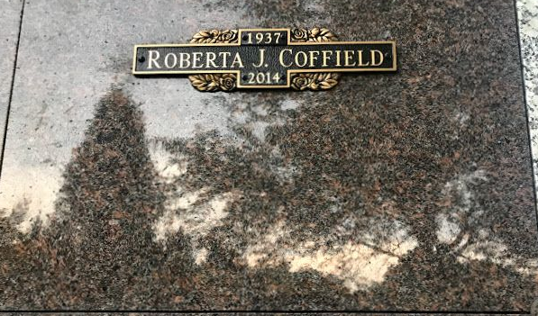
Photo by SMMR

Roberta J. (Crockett) Coffield, 76, of Bluffton, IN, passed away at 5:53 PM on Thursday, April 24, 2014 at Lutheran Hospital of Indiana in Fort Wayne, IN. She was born on Friday, October 15, 1937 in Fiat, IN. She married Ronald Coffield on Sunday, September 08, 1957 in Bluffton, Indiana.
Roberta was a 1955 graduate of Pennville High School. She retired from Corning Glass in Bluffton, IN. She enjoyed gardening, canning, her family, and spending time in Orange Beach, AL. Survivors include: Husband - Ronald Coffield, Bluffton, IN, Daughter - Sheila (Mike Malnor) Soto, Fort Wayne, IN, Sons - Rod (Melissa) Coffield, Senoia, GA and Bert (Amy) Coffield, Ossian, IN, Sisters - Ruby (Harry) Johnson, Yoder, IN and Dorotha (Joy) Teagle, Hartford City, IN, 10- Grandchildren, 12- Great Grandchildren, Several Nieces & Nephews and Several Great Nieces & Nephews. She was a Honorary Adopted Grandmother to many.
She was preceded in death by: Parents - Bert Otis & Mary A. (Plummer) Crockett, Brother – Charles Crockett and 2 Sisters - Rachel Pfeifer and Ruth Schneider.
Family and friends may gather to share and remember at Walker & Glancy Funeral Home, 109 W Windsor St., Montpelier, IN on Sunday, April 27, 2014 from 2:00 PM to 8:00 PM. A service to celebrate Roberta's life will be at Walker & Glancy Funeral Home at 1:00 PM on Monday, April 21, 2014. Interment will be in the Fairview Cemetery in Bluffton, IN.
In lieu of flowers please send donations to Wounded Warrior Project @woundedwarriorproject.org

Walker & Glancy Funeral Home, Blackford County, Indiana
April 25, 2014

