Emma Gertrude (Fryback) Coffield
November 8, 1907 – May 13, 1987

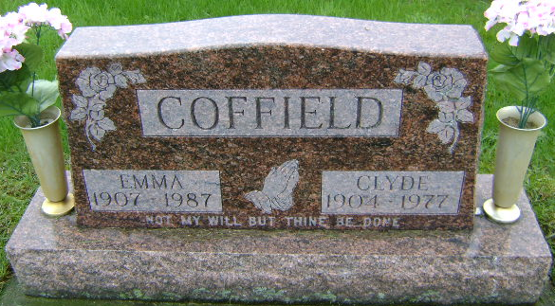
Photo by Bruce Sonner

Emma Coffield, 79, Dies After Year Illness; Services Friday
Mrs. Emma Coffield, 79, widow of Clyde A. Coffield died at 6 a.m. today of heart failure at Meadowvale Care Center following an illness of the past year.
Mrs. Coffield, who formerly resided at 922 West Washington St. was born at Terre Haute Nov. 8, 1907, a daughter of William and Ida Roop Fryback. Her marriage to Clyde Coffield, who died Nov. 9, 1977, took place Jan. 23, 1926 in Bluffton.
Surviving are two sons, Rex M. Coffield, rural Bluffton, and Ron G. Coffield of Bluffton; one daughter, Mrs. William (Betty) Sawyer of Bluffton, six grandchildren and nine great-grandchildren.
Services will be at 1:30 p.m. Friday at the Goodwin Memorial Chapel with Rev. Garry D. Beechler officiating. Burial will be in Fairview Cemetery. Calling at the funeral home will begin at 1 p.m. Thursday. Preferred are memorials to the Wells County Heart Association.

News Banner, Wells County, Indiana
May 13, 1987
**
BLUFFTON - Emma Coffield, 79, died about 6 a.m. Wednesday in Meadowvale Care Center. Her husband, Clyde, died in 1977. Surviving are two sons, Rex and Ronald, both of Bluffton; a daughter, Betty Sawyer, of Bluffton; and six grandchildren. Services at 1 p.m. Friday at Goodwin Memorial Chapel, with calling after 1 p.m. today. Memorials to Wells County Heart Association.

Fort Wayne Journal Gazette, Allen County, Indiana
Thursday, May 14, 1987

