Clyde A. Coffield
July 11, 1904 – November 9, 1977

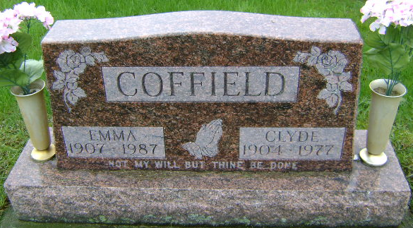
Photo by Bruce Sonner

Clyde Coffield, 73, Has Fatal Heart Attack

A retired 49-year employee at General Electric Co. in Fort Wayne, Clyde A. Coffield, 73, died of a heart attack at 4:45 p.m. Wednesday at Wells Community Hospital. When Mr. Coffield became ill at his home at 922 West Washington St. at 2 p.m. Wednesday, the EMS ambulance was summoned and he was taken to the hospital, where efforts in the coronary care unit were to no avail.
Having suffered a previous attack 16 years ago, Mr. Coffield had been in relatively good health until experiencing discomforts the past two months. Employed over 40 years at General Co., Mr. Coffield retired in 1969. He attended Grace Baptist Church.
Born July 11, 1903 (sic), in Wells county, he was a son of Alexander and Sarah Hadden Coffield. His marriage to Emma Fryback, who survives, took place Jan. 23, 1926, in Bluffton.
In addition to the wife, he is survived by two sons, Rex N. of Bluffton Route 4 and Ronald G., Bluffton Route 2; a daughter, Mrs. William (Betty) Sawyer of Bluffton Route 2; two sisters, Mrs. Julia Scott of Littleton, Colo., and Mrs. Howard (Nettie) Markley of Montpelier; two brothers, Nate Coffield of Montpelier and Marcus Zona Coffield of Bluffton Route 4; six grandchildren and five great-grandchildren.
Friends will be received after 7 p.m. today at the Goodwin Memorial Chapel, where serviced at 10:30 a.m. Saturday will be in charge of Rev. Edward Johnson and Alton Miller. Burial will be in Fairview Cemetery.

News Banner, Wells County, Indiana
Thursday, Nov. 10, 1977

